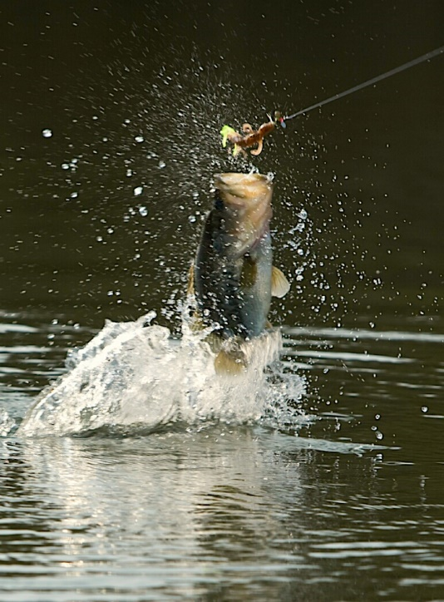
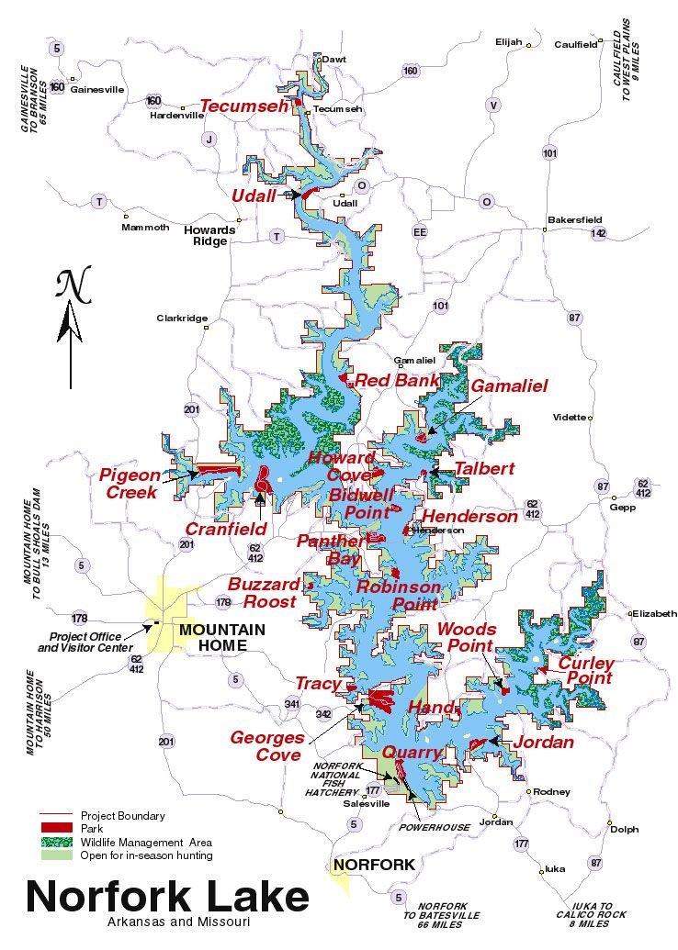
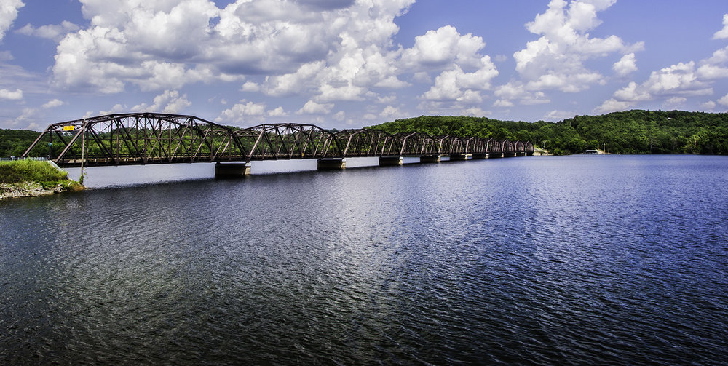
OZARK COUNTY LAKES
Bull Shoals Lake is a reservoir in the Ozark Mountains of northern Arkansas and southern Missouri. It has hundreds of miles of lake arms and coves perfect for boating, water sports, swimming, and fishing. Nineteen developed parks around the shoreline provide campgrounds, boat launches, swim areas, and marinas.
Bull Shoals Lake diverts the White River for the last time as it travels toward the Mississippi. The last in a chain of four, Beaver Lake, Table Rock Lake and Lake Taneycomo.
The shoreline is undeveloped, heavily forested and protected by a buffer zone owned and managed by the Army Corps of Engineers, known as the Corp Take Line.
Bull Shoals covers 70,000 acres, with one thousand miles of shoreline.
Norfork Lake covers 22,000 acres (8,900 ha) with more than 550 miles (890 km) of shoreline. There are 19 recreational parks on the lake that provide places for camping, hiking, picnicking, swimming, boating, and water skiing. Commercial docks on Norfork Lake provide boats, motors, diving equipment, and guides to the lake. Most of Norfork lake lies within Baxter County, Arkansas, with its Northern most portion in Ozark County in Missouri.

