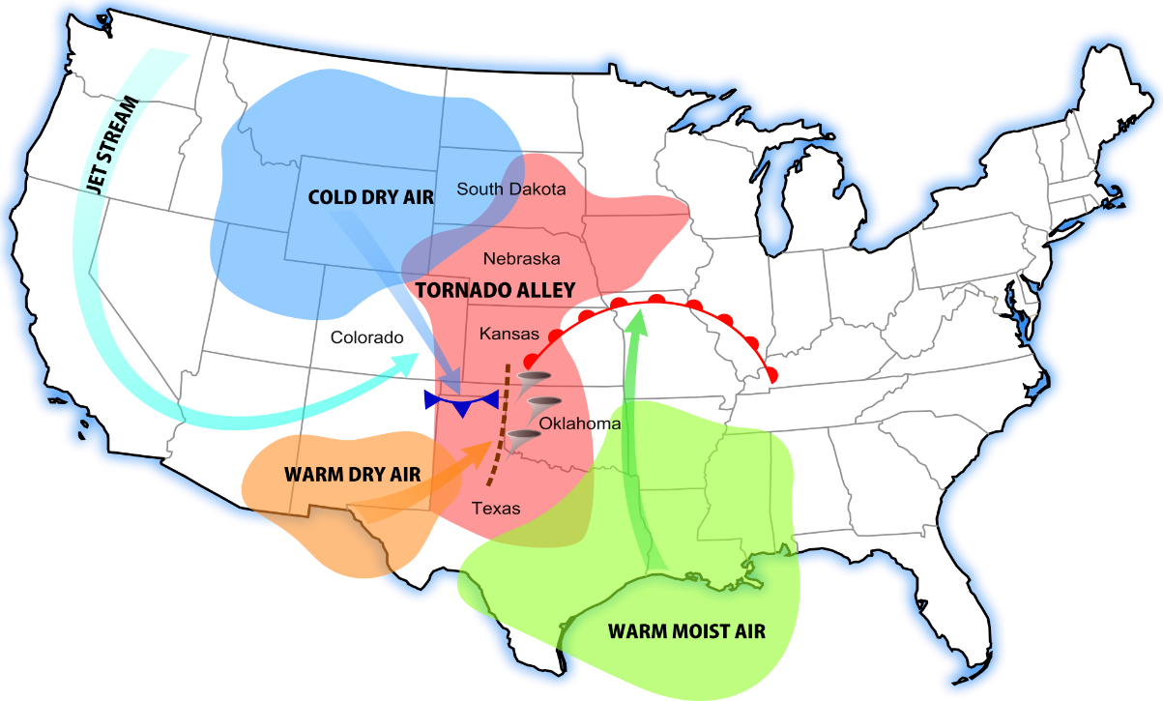
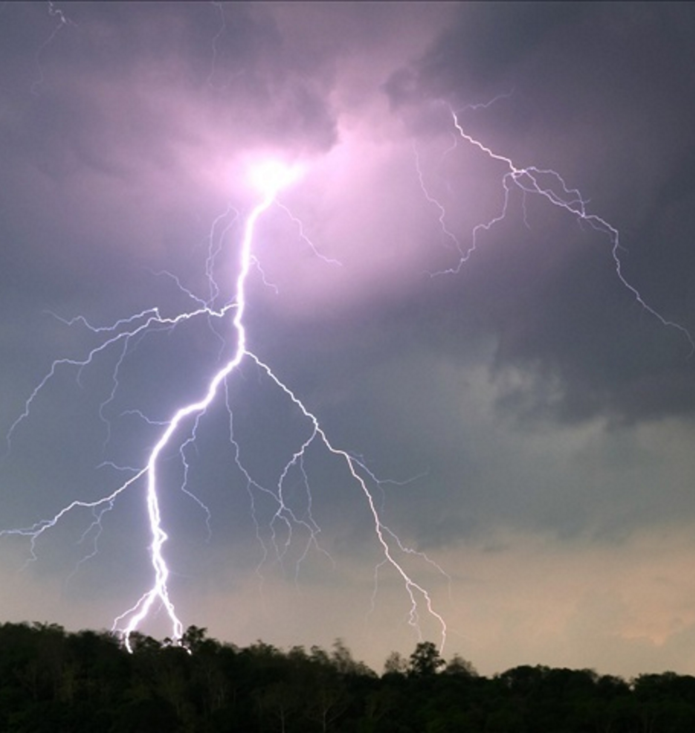
43” average rainfall, keeps our forests lush and green.
SOUTHERN MISSOURI WEATHER
September, May and June are the most pleasant months, while January and December are the least comfortable months.
July high is around 88 degrees
January low is 20 degrees
Rain averages 43 inches of rain a year
Snow averages 13 inches of snow a year. Usually just an inch or two and gone in a day.
Tornados can happen anywhere, but we are not in Tornado Alley.
The Supercell Storms that hit in the Spring are straight line winds, hail, and sometimes tornados. The counties to the West and up in the high plain see the worst of these storms.
Flash Flooding happens when the hills shed all the rain raising the creeks and rivers very quickly. But they go back down as soon as the excess water has passed.
Graphic By Dan Craggs - Own work, CC BY-SA 3.0, https://commons.wikimedia.org/w/index.php?curid=7843081

