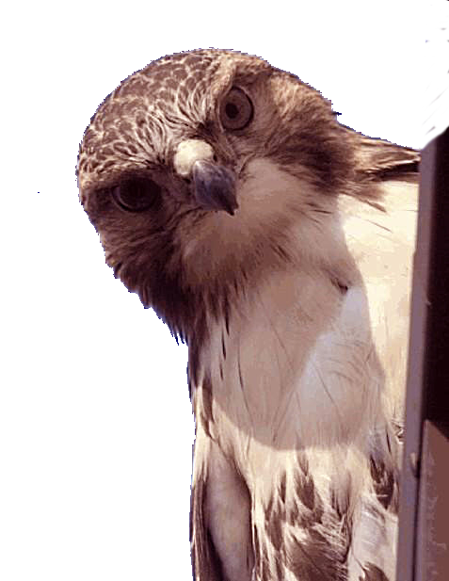
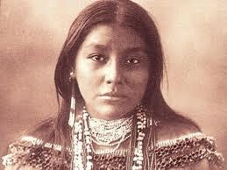
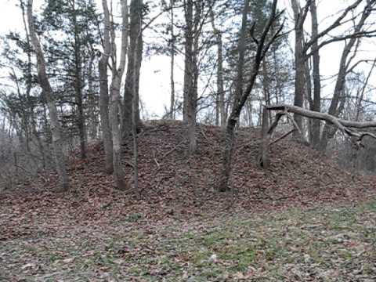
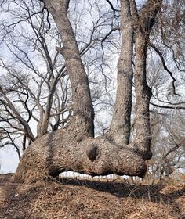
TRACES OF THE ANCIENTS
You can find signs of native indian tribes all over the Ozarks. arrowheads are common and the chips of stone that came from the making of arrowheads. People have lived in the Ozarks for thousands and thousands of years, and there are still traces of the ancients here.
July 12, 1804. A dozen Osage men and two boys, the first of
three Indian delegations to visit Mr. Jefferson during his two administrations, had arrived in Washington City the previous day, escorted by Peter Chouteau, a prominent St. Louis fur trader and the government's first agent to the Osages. On the 13th the President wrote to Secretary of the Navy Robert Smith, "They are the finest men we have ever seen. They were certainly the most gigantic men we have ever seen."
TRAIL TREES
Over the Ozarks you can run across Indian Trail Trees. A sapling would be pinned to the ground to mark the direction to a water source, or direction change in a trail.
The ones that still exist are enormous and easy to spot because of their unique configuration.
INDIAN MOUNDS
692 Mounds found in Douglas County.
No one has determined what they
were built to do.

