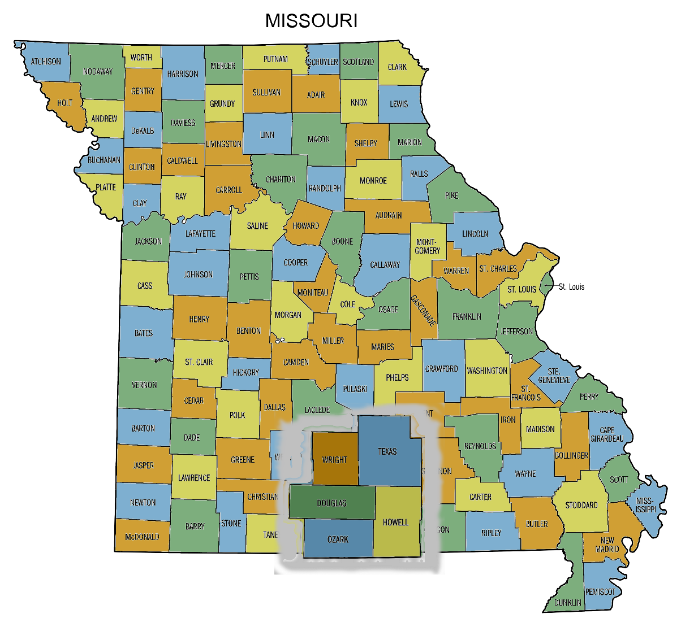
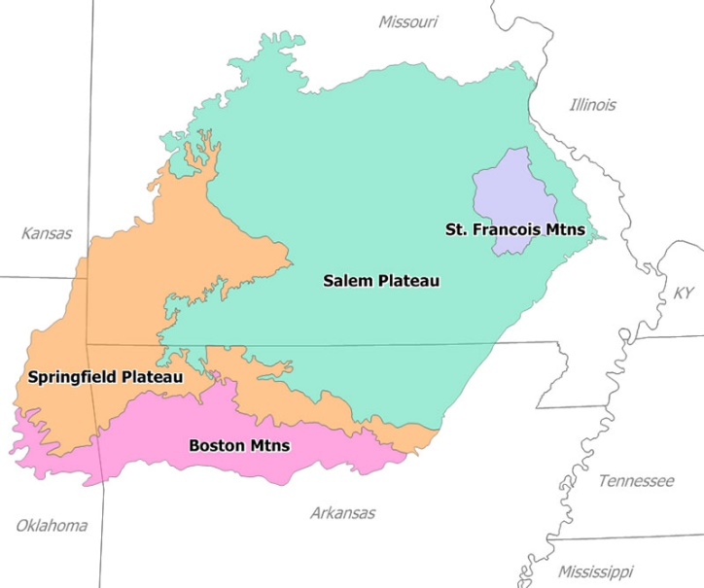
South Central Missouri
The heart of the Ozark Mountains. The terrain changes from near level to
gently rolling to steep ridges.
Rural even Remote, Fewer People. There are places where you can climb a ridge on narrow gravel road that suddenly opens at the top into acres of gently rolling pastures, or drop into a hollow that hides a crystal clear stream and small clearings in a forest of Black Walnut and Oaks.
More Amenities & Local Activities
Growing areas with lots of restaurants, movie theaters, things to see and do, close to the Highway 65 corridor for easy job commute that still have that small town feel, a slower pace, with peace and quiet.
The Ozark Mountain Region covers parts of Missouri, Arkansas, and Oklahoma.
The information in this Relocation Guide will concentrate on five counties in the South-Central part of Missouri.

