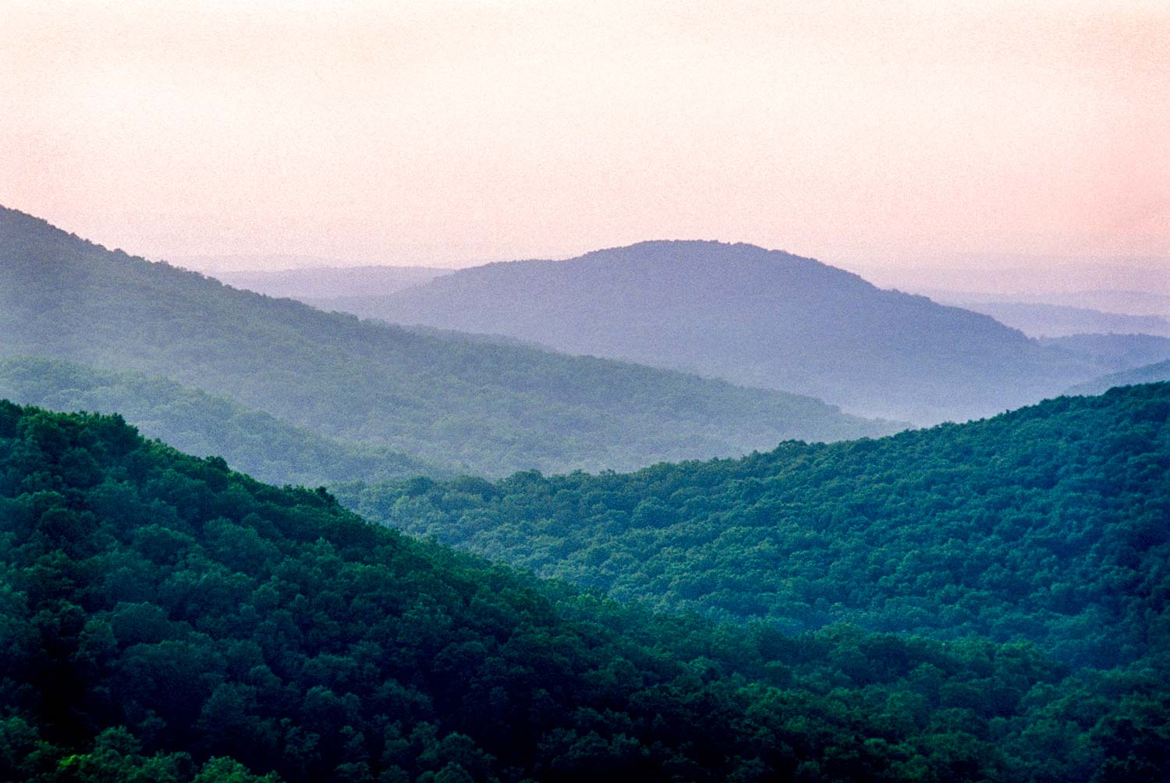


Life in the heart of the Ozark Mountains of Missouri
Five South Central Counties in South Central Missouri
South Central Missouri
Relocation Guide
OZARK MOUNTAINS
Meet Your Local Expert Agent Sheila Wiley
Meet Your Local Expert Sheila Wiley Pg 2

